Abstract— We present a paper based on the design of a platform game. The design of the game is meant to teach the solution of problems of our environment, like pollution, global warming, recycling and species extinction. The area of Educational Technology is still not so developed that it is suitable for young learners. Explaining serious environmental issues to the children and young learners is very difficult through text books. An interactive technology is required for learning effectively and efficiently. We attempt to address this issue and the result is Gombli.
Environment Educational Game Design
Maya Agarwal¹, Bengal Institute of Technology, WBUT, India
Shubhajit Saha², Bengal Engineering and Science University, Shibpur, India
¹maya.agarwal2@gmail.com, ²shubhajit.saha@students.becs.ac.in
Index Terms — Environment, Digital Learning, Game Design.

INTRODUCTION
TECHNOLOGY can be used for teaching in the classroom. In the last decade, technology has bring revolution in the form of teaching from the use of calculator, computer, Distance learning, E-learning etc [1, 2]. Digital gaming technologies help us to explain concepts in a new way that would otherwise not be possible, efficient, or effective, with other instructional methods [3]. Game based learning amplifies the potential of computer games and design techniques. Many digital games were designed in the last decade to teach about learning computer Science [4], History [5], Boolean Logic [6]. Although Digital learning games are simplified caricature of e-learning, it is more engaging experience that can bring behavioral changes. Games encourage application of knowledge, creativity and problem solving skills that cannot be gained by reading texts [7]. In our current work we design a game to teach critical environmental problems to young learners. This paper is organized as follows. First we discuss the Game Description. Second, we discuss the details of the different objects used in the game.Then we describe how to use the game for teaching environment Last, we report our findings from a user study with a group of students.
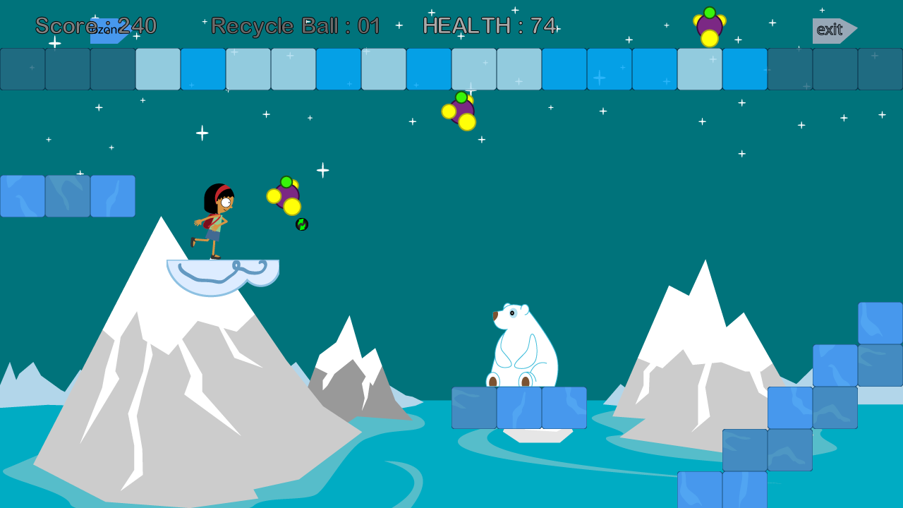
Fig. 1. Player is using recycle ball to swipe out all the molecules of chlorofluorocarbon before reaching exit.

Game Description
A single user horizontal scrolling platform Game, where our game character Gombli is an 11 year old girl represents the player. In the game, the player controls Gombli through a platform collecting all the power-ups. The power-ups of the game are Recycle ball and Bean seed which will pop up randomly on her way. Gombli will fight with two pollutants Carbon dioxide and Chlorofluorocarbon using her collectables (see Fig. 1). Both the pollutants move in a certain area on the platform. Polar beer and Penguin are added as obstacles of the game. Polar beer is a static obstacle and Penguin is dynamic. To avoid contact with these obstacles the player can jump over them. The player loses health when it touches the game obstacles or pollutants.
When all the power-ups are collected and Gombli reaches the exit of the game it moves to the next stage. When the health of player reaches zero the game ends. The main goal of the game play is to remove pollutants and plant trees.

Basic Game Objects

Power-ups
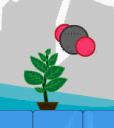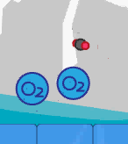
Fig. 2. Carbon dioxide is getting absorbed by Bean plant

.

Bean Seed
When the player throws a bean seed, a bean plant grows. When the pollutant comes in contact with bean plant, it absorbs the incoming pollutant like Carbon Dioxide and releases Oxygen (see Fig. 2).

Recycle Ball
This power up is designed to be more powerful in comparison to Bean Seed. When a Recycle ball is used by the player it swipes out all the pollutants present in the game frame.

Game Enemy: Carbon dioxide and Chlorofluorocarbon
They move in a certain region. The player can defeat them by using power-ups. The player’s health decreases when she comes in contact with them.

Obstacles: Polar Beer and Penguin
These two aquatic animals are chosen to be obstacles in the game play. The player has to avoid her contact with these creatures by jumping over them. Otherwise the player will lose some health points.

How to Use the Game to Teach About Environment
We develop an educational game focused on two components teaching and game play. Both the components are included in equal ratio to make the game more engaging and entertaining. The goal of the game is to “clean the environment and green the environment”. It helps us to instill the spirit of “Save Earth” among the players. Most challenging environmental problems like Depletion of ozone layer, pollutants like Carbon dioxide and Chlorofluorocarbon are used in the design of Gombli to remind the student about our environmental problems and harmful effects of effluents, and thus to improve their learning. Carbon dioxide and Chlorofluorocarbon are chosen to be game enemy as carbon footprint is among the greatest concerns of environmental protection programs and initiatives [8]. The game rule tuning activities involving the use of Recycle ball and Bean seed as power-ups teach the player the importance of growing plants and recycling old things. Recycle ball is designed to be more powerful to make students realize that recycling is the need of the hour. Most complex environmental problems like pollution, emissions of green house gases, global warming can be solved by recycling [9].Whenever a player uses a recycle ball in the game play it leaves deep impact on their mind about its requirement. Health of the player decreases when they come in contact with pollutants. It highlights the harmful effects of the poisonous gases on human health.
From the research it has been found that human beings are driving force for species extinction [10]. Penguin and Polar beer are chosen as obstacles, as both are endangered species. When player touches these animals, the player’s health decreases. It conveys a message that humans should not interfere with animal’s life to stop them from getting extinct.
The most essential component of the game is fun and entertainment. It keeps students engaged with the game for long time.

Implementation
The platform chosen to design Gombli is Microsoft XNA [11] cross-platform game engine, using C# object-oriented technology. With the help of XNA game studio it was easier to implement the entire game as it handles graphics device, networking and game loop.

User Study
To evaluate the learning achievement through our game, we formed a group of 50 students selected randomly from sixth and seventh Grade to understand the play experience and improve the game design [15]. The research questions were designed to gather the feedback to improve Gombli and see how the design was helpful in learning about our environment. It also determined how the characterization of the pollutants helped to grab the attention of the young learners. Our main goal is to realize how learning games can grasp the interest of the player and how much knowledge they gain after playing the game. We hope to understand the patterns of learning among children through games. A researcher took observation notes during game play, to record interesting movements of play and to generate related questions for the interview. The observation included how the player interacts and the reaction of the player on their first interaction with the game play. At the end of the user study, we conducted a semi-structured interview. The interview focused on understanding the subjective experience of the players, including the strategies they adopted, things they learned, what made them adhere to the game.
We got positive feedback about Gombli (see Table. 1). As a part of the survey we asked the students to rate our game on a scale of 1 to 5. The parameters chosen were Learning, Fun, and Want to play again.
TABLE I
Feedback Score
Rating | Learning | Fun | Want to play again
0 – 1.5 | 5 | 7 | 13
1.5 – 3.5 | 13 | 27 | 27
3.5 – 5.0 | 78 | 65 | 60
The rating values of all the parameters are calculated as the percentage of total students.

Conclusion And Future Work
Educational game is a vast field of research due to its high potential. Gombli is effective in spreading awareness about our environmental problems. It helps students to grasp complex issues in an entertaining method. Our Next focus is application and evaluation of all eight millennium goals [13, 14]. We have plans to implement the game in mobile Java platforms, as mobile phones are low-power device and used by billions of people [15].
References
- Groff, J., & Haas, J. (2008). Groff, J., & Haas, J. (2008). Web 2.0: Today’s technology, tomorrow’s learning. Learning & Leading with Technology, September/October 2008.
- Groff, J., & Mouza, C. (2008). A framework for addressing challenges to classroom technology use. Association for the Advancement of Computing in Education (AACE) Journal, 16(1), 21-46.
- Prensky, M. (2001). Digital game-based learning. New York: McGraw Hill.
- Teaching Computer Science through Game Design Mark Overmars, Utrecht University.
- Nor Azan Mat Zin 1, Wong Seng Yue 2 History Educational Games Design Faculty of Information Science and Technology, National
- Teaching Boolean Logic through Game Rule Tuning Jui-Feng Weng, Shian-Shyong Tseng, Member, IEEE, and Tsung-Ju Lee
- Annetta, L.A. and Cheng, Meng-Tzu. Why educational video games?In. Annetta, L.A. Serious educational games: from theory to practice,Sense Publishers, Rotterdam, 2008.
- ENVIRONMENTAL SCIENCE: THE WAY THE WORLD WORKS - Bernard Nebel; Richard Wright. bernard-nebel-richard-wright.comprar-livro.com.br/livros/1013083134/
- Xiang Zuo-yi; Zhao Feng; Bus. Sch., Central South Univ., Changsha, China Research on Waste Mobile Recycling Network Model and Application in the Context of E-commerce
- Joby Warrick, Mass Extinction Underway, Majority of Biologists Say [FINAL Edition]The Washington Post - Washington, D.C., A.04, Apr 21, 1998
- Microsoft, App Hub, http://create.msdn.com/, March 4, 2004.
- Barbara M. Wildemuth, Why Conduct User Studies? The Role of Empirical Evidence in Improving the Practice of Librarianship. Proceedings of INFORUM 2003: 9th Conference on Professional Information Resources, Prague, May 27-29, 2003.
- Microsoft Imagine Cup theme, “Imagine a world where technology helps solve the toughest problems." http://www.imaginecup.com/CompetitionsContent/2012Theme.aspx
- United Nation Millennium Development Goals, Background, http://www.un.org/millenniumgoals/bkgd.shtml
- CNN. Weapon against epidemics: cellphones. Hhttp://edition.cnn.com/2009/TECH/science/06/16/cellphones.health.disease/H (Last accessed September 17, 2009).

 

